Semester 1 2021

ATAR course examination

Question/Answer booklet

**Year 11 ATAR COMPUTER SCIENCE AECSC**

Surname:

Other names:

WA student number (if known)

SIDE Teacher:

SIDE Student Coordinator:

**Supervisor’s declaration**

I declare that this examination paper has been completed by the student named above. The time and resource restrictions have been observed and the student has NOT accessed notes, texts, reference books, the internet, a computer, a calculator or a mobile phone unless otherwise specified. I understand that breaches of the examination rules could lead to an examination paper being cancelled or having an examination mark significantly lowered.

Supervisor’s name:

Signature: Date:

**Time allowed for this paper**

Reading time before commencing work: ten minutes

Working time: two and a half hours

**Materials required/recommended for this paper**

***To be provided by the supervisor***

This Question/Answer booklet

***To be provided by the candidate***

Standard items: pens (blue/black preferred), pencils (including coloured), sharpener, correction fluid/tape, eraser, ruler, highlighters

Special items: up to three calculators, which do not have the capacity to create or store programmes or text, are permitted in this ATAR course examination, Mathomat and/or Mathaid and/or any system flowchart template

**Important note to candidates**

No other items may be taken into the examination room. It is **your** responsibility to ensure that you do not have unauthorised material. If you have any unauthorised material with you, hand it to the supervisor **before** reading any further.

**Structure of this paper**

|  |  |  |  |  |  |
| --- | --- | --- | --- | --- | --- |
| Section | Number of questions available | Number of questions to be answered | Suggested working time (minutes) | Marks available | Percentage of examination |
| Section One:  Short answer | 20 | 20 | 60 | 76 | 40 |
| Section Two:  Extended answer | 6 | 6 | 90 | 74 | 60 |
|  |  |  |  | **Total** | 100 |

**Instructions to candidates**

1. The rules for the conduct of Western Australian external examinations are detailed in the *Year 12 Information Handbook 2021*. Sitting this examination implies that you agree to abide by these rules.

2. Write your answers in the spaces provided in this Question/Answer Booklet. A blue or black ballpoint or ink pen should be used. Wherever appropriate, fully labelled diagrams, tables and examples should be used to illustrate and support your answers.

3. You must be careful to confine your responses to the specific questions asked and to follow any instructions that are specific to a particular question. Where no specific instructions are given, you should feel free to use a range of formats to express your knowledge and understandings.

4. Spare pages are included at the end of this booklet. They can be used for planning your responses and/or as additional space if required to continue an answer.

* Planning: If you use the spare pages for planning, indicate this clearly at the top of the page.
  + Continuing an answer: If you need to use the space to continue an answer, indicate in the original answer space where the answer is continued, i.e. give the page number. Fill in the number of the question(s) that you are continuing to answer at the top of the page.

**Section 1: Short Answer 40%(76 Marks)**

This section contains **20** questions. You must answer **all** questions. Write your answers in the spaces provided.

Spare pages are included at the end of this booklet. They can be used for planning your responses and/or as additional space if required to continue to answer.

* Planning: If you use the spare pages for planning, indicate this clearly at the top of the page.
* Continuing an answer: If you need to use the space to continue an answer, indicate in the original answer space where the answer is continued, i.e. give the page number. Fill in the number of the question that you are continuing to answer at the top of the page.

Suggested working time: 70 minutes.

**Question 1 (3 marks)**

Discuss the role of cache memory in a system.

**Question 2 (4 marks)**

Outline how the boot process powers up a system.

**Question 3 (4 marks)**

Complete the following table?

|  |  |
| --- | --- |
| **Term** | **Size** |
| Byte | 8 bits |
| Kilobyte |  |
| Megabyte |  |
| Gigabyte |  |
| Terabyte |  |

**Question 4 (2 marks)**

Identify the role of a Standard Operating System.

**Question 5 (4 marks)**

Describe what happens during the fetch-execute cycle.

**Question 6 (2 marks)**

Discuss the difference between primary and secondary storage.

**Question 7 (13 marks)**

Consider the following table for an online plant ordering service. This flat file database stored information about where the plant was bought to display in the online store. It also identifies who the original plant breeder or developer was.

|  |  |  |  |  |  |  |  |
| --- | --- | --- | --- | --- | --- | --- | --- |
| Plant ID | Plant Name | Nursery ID | Nursery Name | Cost | Release Date | Developer ID | Developer  Name |
| J21 | Nitricous | 365 | PlantyPlants | $15 | 21/10/2020 | 234G | Abc |
| J22 | Rosie | 444 | Greens | $12 | 15/11/2020 | 234G | Abc |
| E44 | Mirtle | 445 | Flowerz | $15 | 23/5/2020 | 453N | DEF |
| J21 | Nitricous | 365 | Flowerz | $13 | 21/10/2020 | 234G | Abc |

1. Discuss the advantages of using a relational database system over the flat file system currently being used in this business. (3 marks)

`

1. Create an entity relationship diagram (ERD) below that reflects the business contained within this flat file database. Show all Primary keys, Foreign keys and attributes. (10 marks)

**Question 8 (5 marks)**

Outline the role of the following components.

Arithmetic logic unit:

Control unit:

Registers:

Program counter:

System clock:

**Question 9 (5 marks)**

You arrive at your computer which you find unresponsive to your input via a keyboard. Document a troubleshooting procedure for this situation below.

**Question 10 (2 marks)**

Discuss the purpose of an ICT Code of Conduct?

**Question 11 (3 marks)**

What are the differences and similarities between a mechanical disk and a solid state drive disk.

**Question 12** **(3 marks)**

Data is transferred around the Computer System using the following buses: Data, Address and Control. Discuss these three components in relation to the Fetch-Execute Cycle.

**Question 13 (6 marks)**

A large government bureaucracy has offices across Perth City. Here is a section of the database relations they use

**Employee** (employeeID, EmployeeFirstName, EmployeeSurname, unitNo, streetNo, streetName, suburb)

**Works** (employeeID (FK), departmentID (FK), salary)

**Department** (departmentID, suburb)

1. Using the data, explain what the role of the Foreign Key(s). (2 marks)

1. Which table is the Associative Entity or joining table? (1 mark)

1. How does the Associative Entity reduce redundancy in this set of data? (3 marks)

**Question 14 (8 marks)**

Maxima High School has decided to use FreeWare applications in order to save money on purchasing commercial software packages for basic applications. The changeover from the existing system to the new system will commence with staff. Most of the staff are familiar with using word processors, spreadsheets and presentation packages but have not previously used FreeWare Applications.

To manage this project, discuss how the following project management concepts would apply.

Planning:

Scheduling:

Budgeting:

Tracking:

**Question 15 (3 marks)**

Identify three design considerations for the user interface within a database system.

**Question 16 (3 marks)**

Customers enter sensitive and personal data into a form they access through a website.

Discuss the legal requirements associated with an organization keeping this information.

**Question 17 (2 marks)**

Discuss how a file system undertakes space management.

**Question 18 (2 marks)**

Identify documentation that would be developed when creating a new database.

**Question 19 (4 marks)**

Identify what the following terms mean in relation to databases.

Atomicity:

Data integrity:

Data redundancy:

Relation:

**Question 20 (2 marks)**

1. Identify how the data being entered into the online database can be authenticated.

(1 mark)

1. Identify how the data being entered can be secured (1 mark)

**End of section one**

**Section Two: Extended answer 60% (74 Marks)**

This section has **six (6)** questions. Answer **all** questions. Write your answers in the spaces provided.

Spare pages are included at the end of this booklet. They can be used for planning your responses and/or as additional space if required to continue to answer.

* Planning: If you use the spare pages for planning, indicate this clearly at the top of the page.
* Continuing an answer: If you need to use the space to continue an answer, indicate in the original answer space where the answer is continued, i.e. give the page number. Fill in the number of the question that you are continuing to answer at the top of the page.

Suggested working time: 110 minutes.

**Question 21 (9 marks)**

The organisation’s owners are seriously considering implementing a new system but have the following concerns.

* The organization’s cash flow is critical and they must deliver on their projects or they lose the few significant but profitable clients they have.
* Safety on each site is very important and the organization must comply with many State and Federal legislation regarding workplace safety.
* They are not in a rush but do believe their systems can be made more efficient.
* They want access to more data about their daily business so they can make decisions based on information produced from data that has high integrity.

A commercial landscaping company has found that they need a more efficient system to manage the data created from daily operations within the business. You have been employed to analyse their current data needs and design a system that more effectively manage the processes of quoting, designing and invoicing for their commercial projects.

The description of the system to be developed is as follows:

* A request for a landscape quotation is received via email or via the website.
* The enquiry will be checked to see if it is from an existing customer. If it is a new customer, further details are requested, and a customer card is created and stored in the customer file.
* The sales manager will contact the customer and organise to meet with the customer on site. The sales manager keeps track of his appointments on a wall calendar.
* When the sales manager meets with the client, a client brief is developed. This client brief is taken back to head office to create a quotation.
* The quotation is then provided to the customer and if accepted, a copy is placed with the client brief in a customer file.
* An invoice will be created based on the quotation. This invoice is sent to the client who is required to transfer a 10% deposit upfront.
* Once the 10% deposit is received, the quotation will be used to create a schedule of works. This is sent to the customer for approval. Once approval is received for the schedule, the customer will be required to make the final payments of the project invoice. A commencement notice will be sent to the customer.
* Upon project completion, the customer walks through the works and signs a Completion Form.

Below is an extract of the spreadsheet that the Office Manager uses to keep track of projects, invoices and costs.

1. Considering these factors, recommend which one of the project management methodologies would be most suitable. Justify your response. (5 marks)

1. Explain for the owners what the purpose of a Context Diagram is. (2 marks)

1. A Data Flow Diagram is also required, discuss the purpose of this documentation.

(2 marks)

**Question 22 (14 marks)**

Create a context diagram below for the landscaping business system scenario on page 14 of this booklet.

**Question 23 (23 marks)**

Complete the level 0 Data Flow Diagram for the system below. There are six (6) processes in total and Process 5.0 has been created for you.

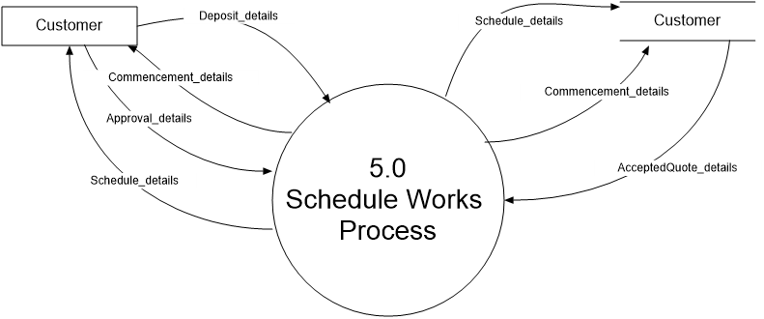­­­

**Question 24 (14 marks)**

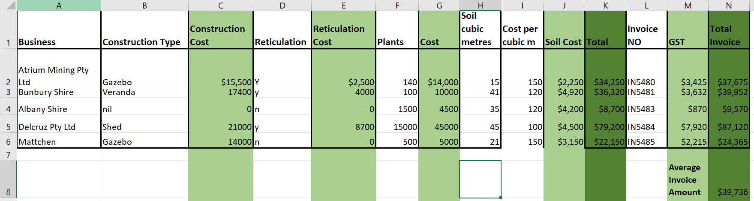

Refer to the information contained in Figure above for the following questions.

1. What formula will be in cells K2:6 (2 marks)

1. Write the formula that will be in cells N2:6 (2 marks)

1. To calculate the average for all invoices, what formula would be in cell N8? (2 marks)

To automate the soil calculation by incorporating the information in the Figure below what formula would be in cells I2:I6 and J2:J6? (8 marks)

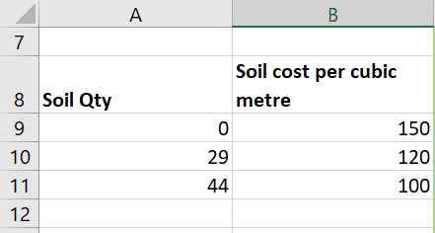

**Question 25 (11 marks)**

Coral is a 76 year old grandmother who uses her computer to check emails, look at photos and videos of her grandchildren and watch youtube videos. Her current system has broken and she wants a replacement. She is happy with the current peripherals (monitor, mouse, keyboard etc). Her current set up is in a small spare room she uses as her office.

|  |  |  |
| --- | --- | --- |
| **Component** | **Option 1** | **Option 2** |
|  | **Intel NUC Performance Kit NUC10i7FNH** |  |
| **CPU** | **i5 10th Gen Quad Core 1.6 GHz with a turbo of 4.20 GHz** | **AMD Ryzen 5 5600X 6 Core 12 Threads CPU up 3.7 to 4.60GHz Turbo Boost** |
| **Size** | **117 x 112 x 51mm** | **531x 462 x 233mm** |
| **Storage** | **1TB 2.5" SATA III 6GB/s V-NAND SSD**  **16 (2*8) GB DDR4 SODIMM Memory** | **32GB (2x 16GB) DDR4**  **1TB M.2 NVMe SSD** |
| **GPU** | **Intel® UHD Graphics** | **GeForce RTX 3060 12GB Overclocked Video Card** |

Compare and contrast each of the components listed in above to justify which system would be best suited to the needs of Coral.

(11 marks)

**Question 26 (3 marks)**

Public Key encryption adds and extra layer of protection in transmitting files over Symmetric encryption

Discuss how these Public Key encryption works and how it improves communication security. (3 marks)

**End of Questions**

Question No

Question No

Question No

End of booklet